GROUP WORK OF PYTHON INSTALLATION ENVIRNOMENT
L5 NIT 16/9/2025
GROUP MEMBERS:
SHEJA Djibril
YESARAKIZA Patience
GIKUNDIRO Mamita

1: Download python
- Visit the official python website through your web browser,,
- Click” downloads” to find the right version according to your OS, may be Windows, Linux or macOS.
- Then Download.
2: Setup installation
- During installation on windows, tick the two boxes for easy running of python within your command line.

- Then click “Install now”. 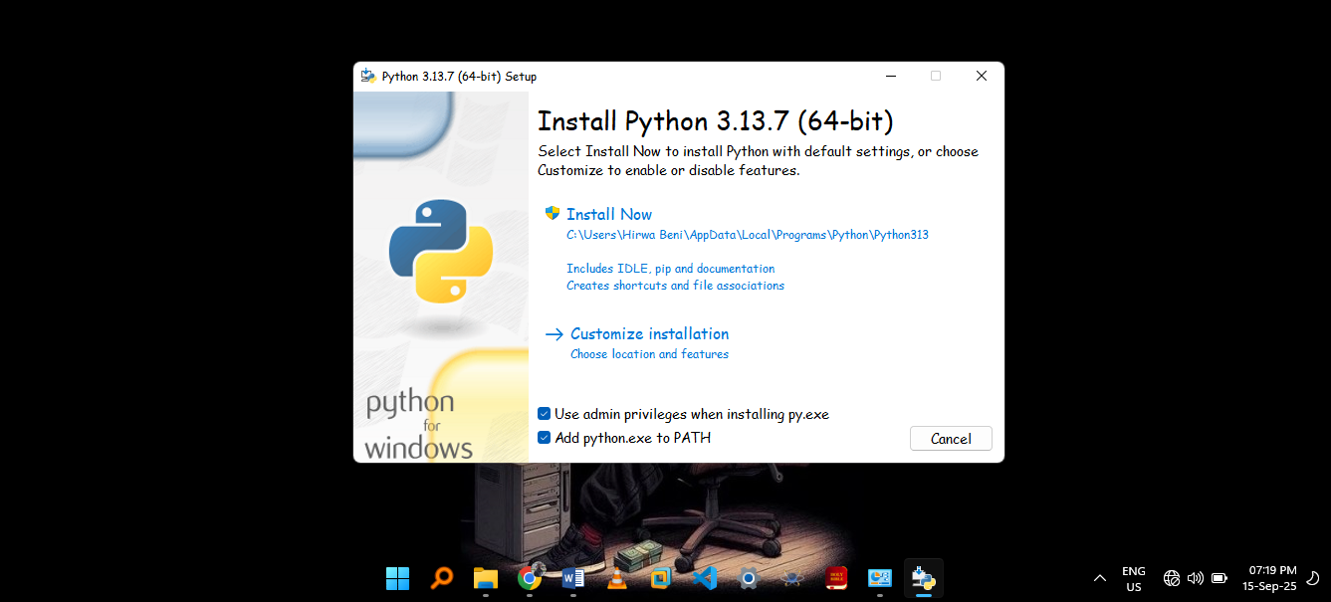
3: Verify the installation
- Open computer’s command line (CMD).

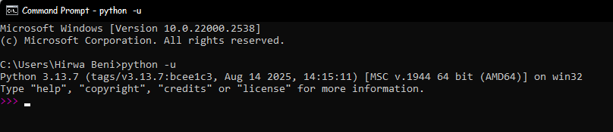
- Then type “python -u” and press Enter.

4: Testing by use of a simple program.

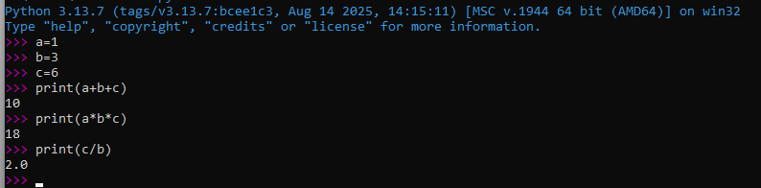
- Above is the simple program for addition, multiplication and division of three numbers.

Thank you for receiving our work at this time.

